Mrs. Morgan’s  Student  News |  | 

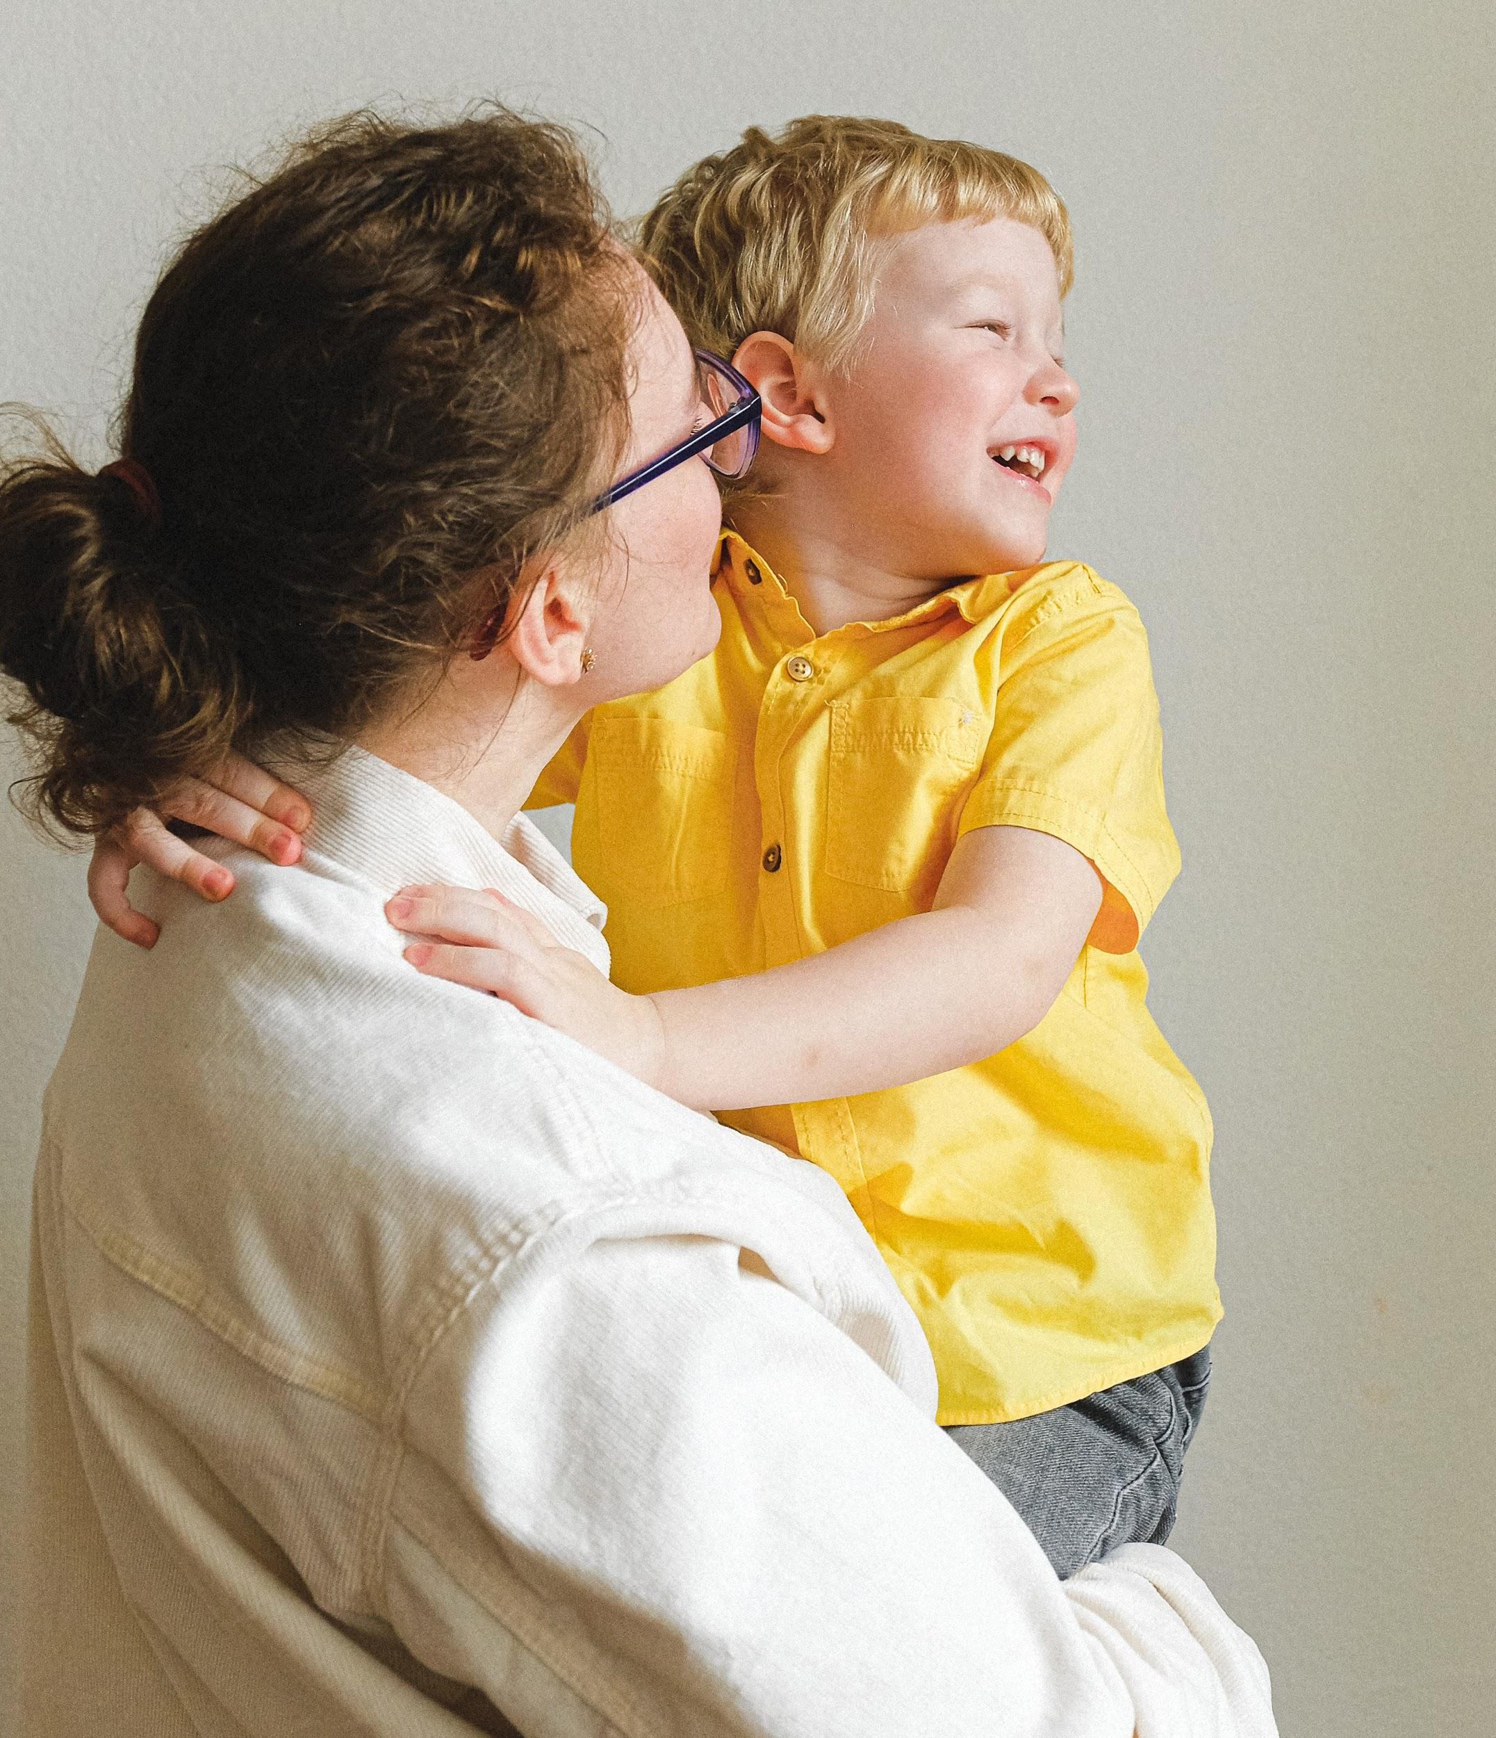 | News for the week of: August 31, 2026  HOMEWORK:  Reading: 20 minutes per night  Spelling Words: perished, debris, turbulence, intrigued, category, sustain, dropsonde, meteorologist, surges, spectacles
WI
 | Content Standards for the Week:  READING: Hurricanes (intoReading)  (SKILLS): Text Features (review)  MATH: test (factors, multiples, prime/composite)
 | Other Communication:  Graded work will come home on Fridays (or whatever day is at the end of the week). Please check for any papers that say “fix” on them. Your child can fix them for a better grade.  September  (4) First Friday  (7) No School  (14) Fall Pictures  (17) Chocolate Sales end  (18) No School  ***Nonfiction Text Features due September 14th***  PLEASE HAVE YOUR CHILD BRING A WATER BOTTLE EVERY DAY ALL YEAR!!

